

**2 Bedroom/1 Bath: 940Sqft (Sand Creek Vista Plan)**

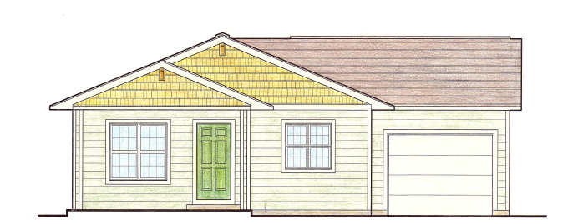





**3 Bedroom/1 Bath: 1162Sqft (Sand Creek Vista Plan)**



