

**2 Bedroom/1 Bath: 940Sqft**

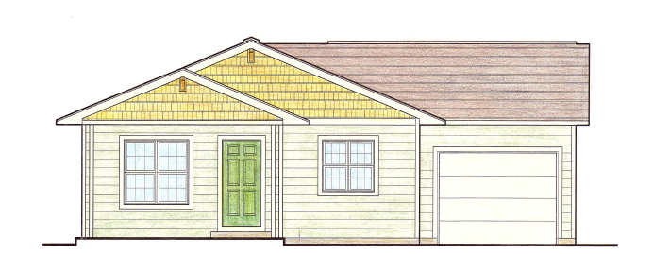





**3 Bedroom/1 Bath: 1160Sqft**

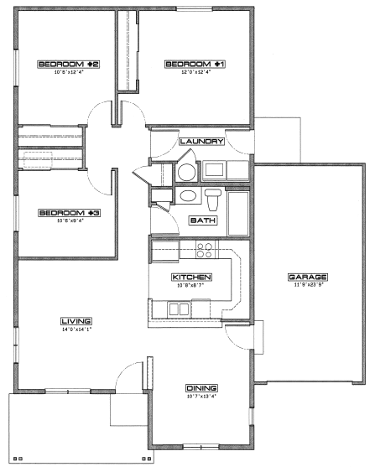



**4 Bedroom/2 Bath: 1344 Sqft**

